Mrs Pamella Musimbi Makotsi Sittoni

P.O. Box 5777 – 00200

Nairobi

Kenya

4th September 2019

To Whom It May Concern,

**RE: ACCESS TO FUNDS IN MY ACCOUNT**

This is to confirm that my daughter, **Chebet Imali Sittoni**, has my permission to access and use funds held in my Nation Savings and Credit Co-Operative (SACCO) Society account, as needed for her tuition and maintenance while studying at the University of Kent.

Yours sincerely,

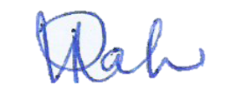

**PAMELLA MUSIMBI MAKOTSI SITTONI**